horizontal line

**UNH SEDS**

33 Academic Way

Durham NH, 03824

Rocket Building 101

**14th February 2020**

# **OVERVIEW**

This document will cover the basics of rocket fundamentals and the process of building an amateur rocket. It is intended to assist the organization in transitioning from the current senior class to the underclassmen that will take the club forward. This document will contain rocket software, general physics, and troubleshooting the build process.

# **ROCKET PHYSICS**

**Forces on a Rocket**

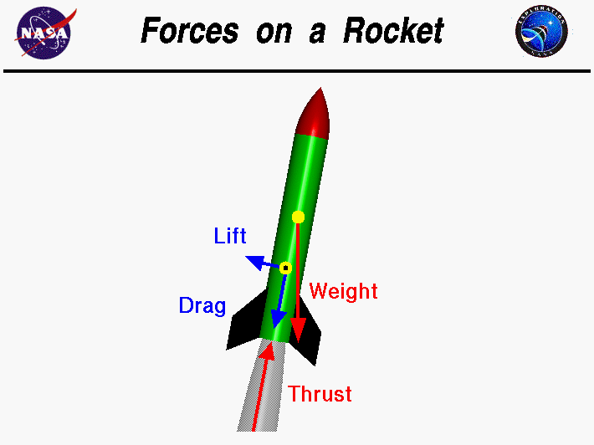

In flight, a rocket is subjected to four forces; weight, thrust, and the aerodynamic forces, lift and drag.

**Rocket Lift**

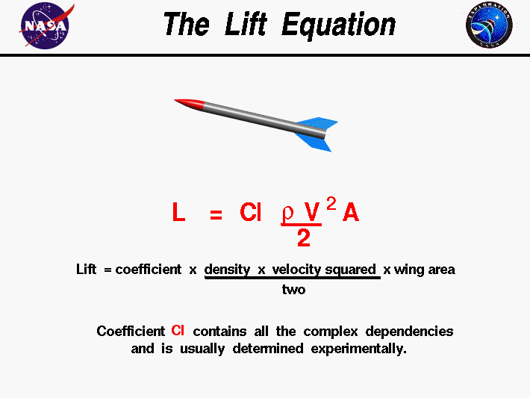

Lift equation: Lift = (½)*(Coefficient of Lift)*(Density of Medium)*(Velocity^2)*(Reference Area)

Note: Coefficient of lift contains all the complex dependencies of flight and is usually determined experimentally or through research.

**Rocket Drag**

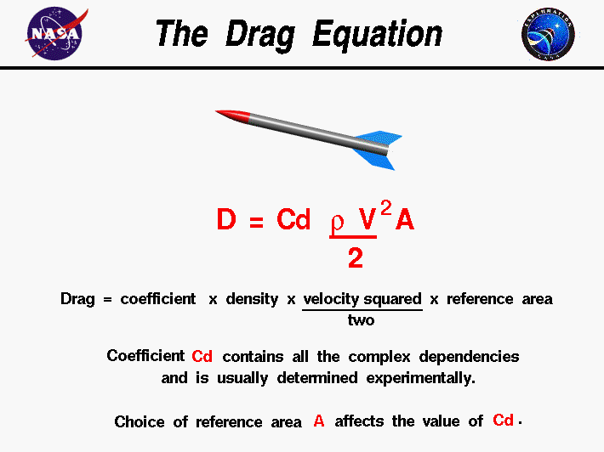

Drag Equation: Drag = (½)*(Coefficient of Drag)*(Density of Medium)*(Velocity^2)*(Reference Area)

Note: Coefficient of Drag contains all the complex dependencies of flight and is usually determined experimentally or through research. Choice of Reference Area will affect the value of Coefficient of Drag.

**Rocket Weight**

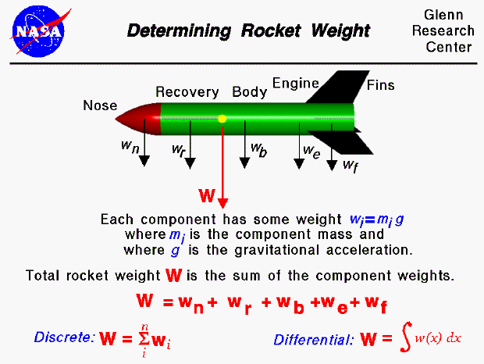

Weight Equation: Weight = (Mass)*(Gravity)

**Rocket Trust**

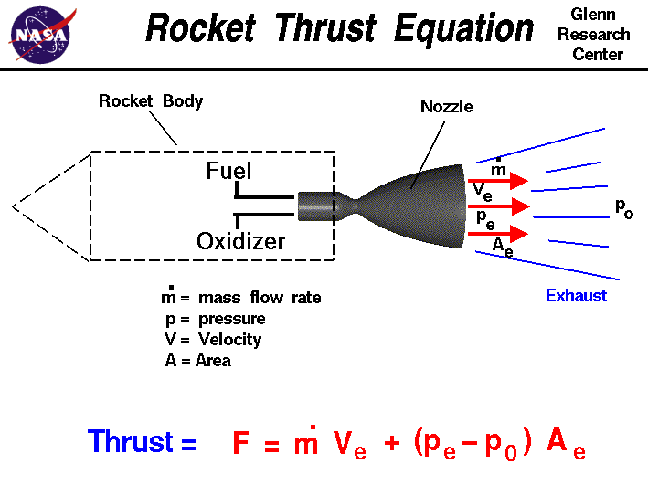

Thrust Equation: Thrust = (Mass flow rate)*(Exit Velocity) + (Exit Pressure - Atmospheric Pressure)*(Exit Area).

Note: Based off of Newton’s Third Law: for every action (force) there is an equal and opposite reaction. In the application of Rocketry, thrust is produced by throwing material in the direction opposite of travel.

**Rocket Stability**

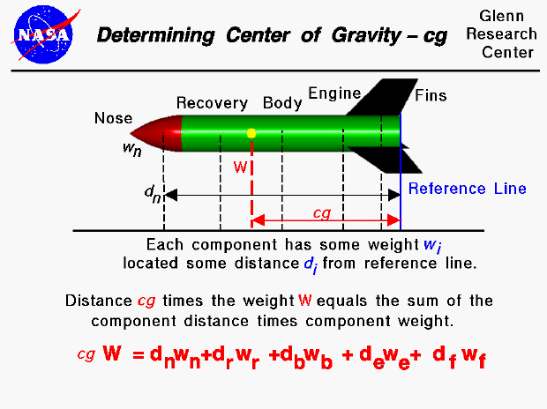

Center of Gravity (CG): Point on rocket where the average weight is located.

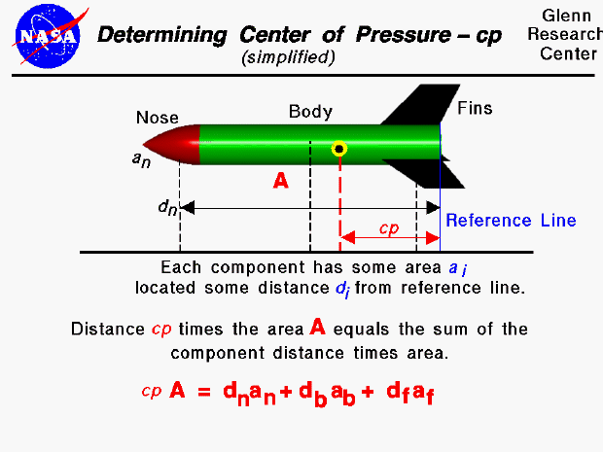

Center of Pressure (CP): Point on the rocket where all the aerodynamic forces act through.

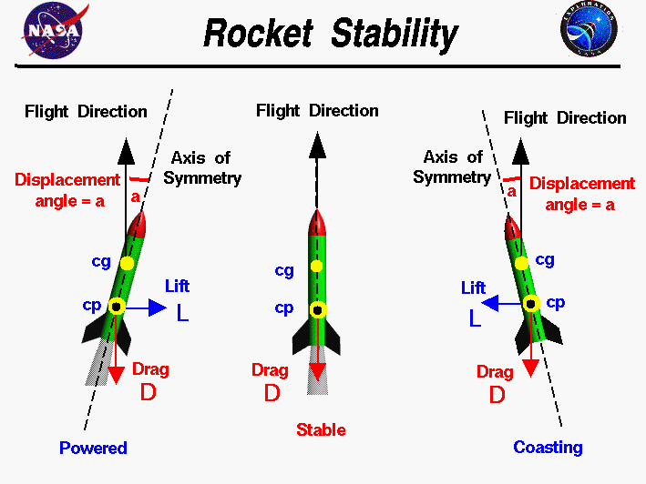

For stable flight, the CG must be in-front of the CP.

**Forces on a Rocket at Liftoff**

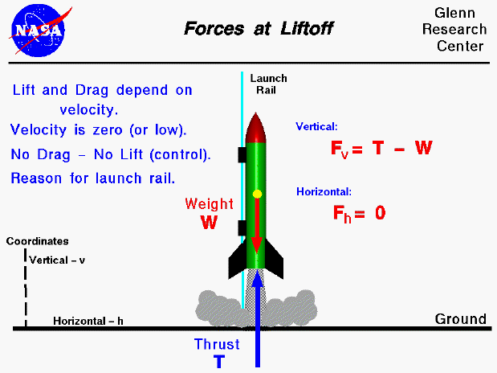

Fv = Forces in the vertical direction

Fh = Forces in the horizontal direction

**Forces on a Rocket coasting in Flight**

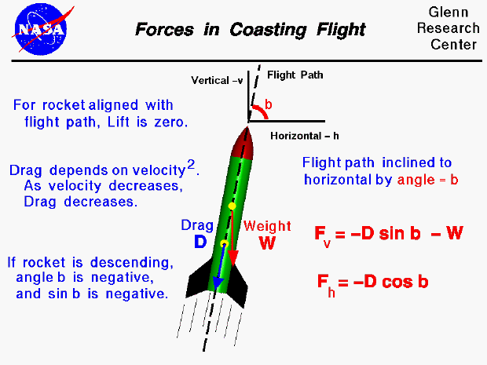

Fv = Forces in the vertical direction

Fh = Forces in the horizontal direction

**Forces on a Rocket during Recovery**

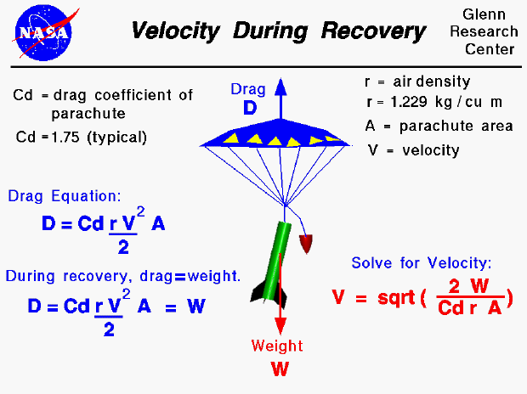

Notes: Drag equation covered earlier.

**Forces on a Rocket during Failed Recovery**

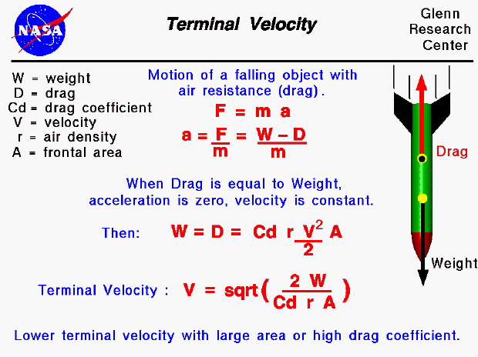

**Tsiolkovsky Rocket Equation**

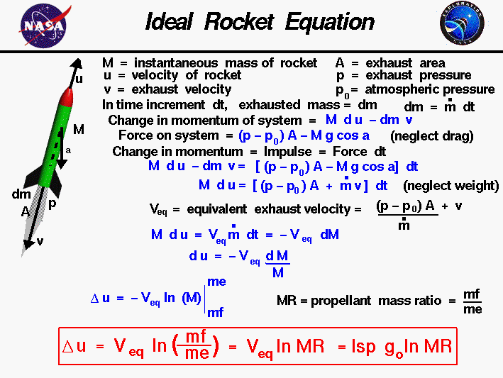

Rocket Equation: Delta V = (Exit Velocity)*ln(Mass Final / Mass Initial)

# **SOFTWARE**

**Open Rocket Software Download**

Google: “Download Java”. Follow first link to <https://java.com/en/download/>

Download Java. OpenRocket requires Java to operate.

Google: “Open Rocket”. Follow first link to <http://openrocket.info/>

Download Open Rocket

**OpenRocket User Interface**

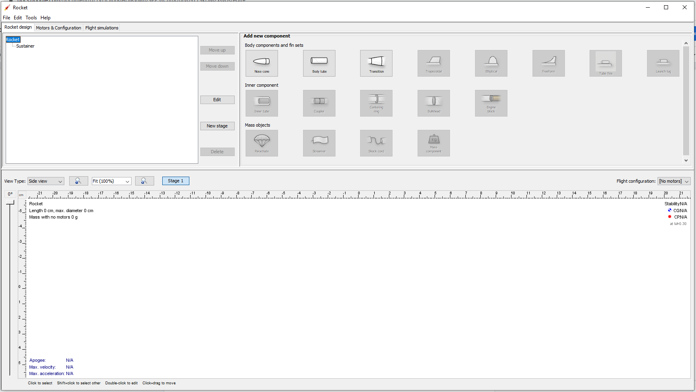

**Trapezoidal Fin Explanation**

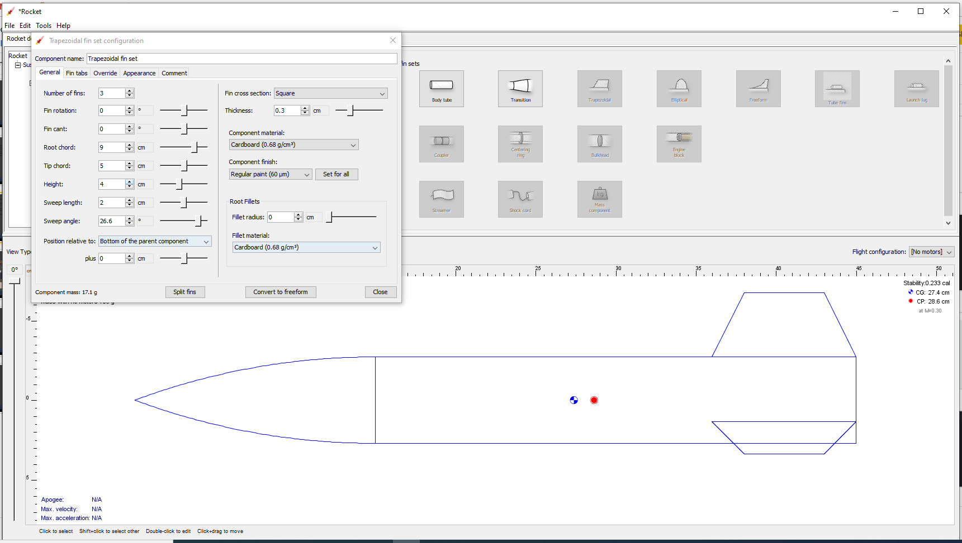

Notes:

Number of fins: 3

Fin rotation: 0 deg

Fin cant: 0 deg

Root chord: “Length of fin base”

Tip chord: “Length of fin tip

Height: “Height of fin from body tube

Sweep length: “Cos(length of first fin length)”

Sweep angle: “Degree of first fin angle”

Position relative to: “Where you want your fin on the body tube.”

**Motors and Configuration Explanation**

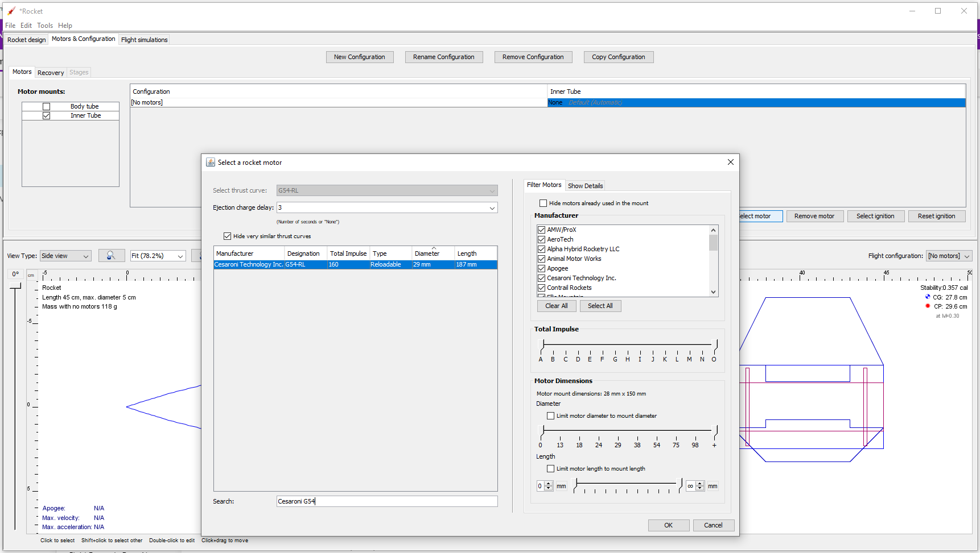

Notes:

Click: “Motors & Configuration”

Click: Inner Tube in “Motor mounts:”

Click: Inner Tube in “Configuration”

Search: Motor (ex. Cesaroni G54 / G125)  
 In Ejection charge delay: 12

Click: OK

**OpenRocket Critical Elements**

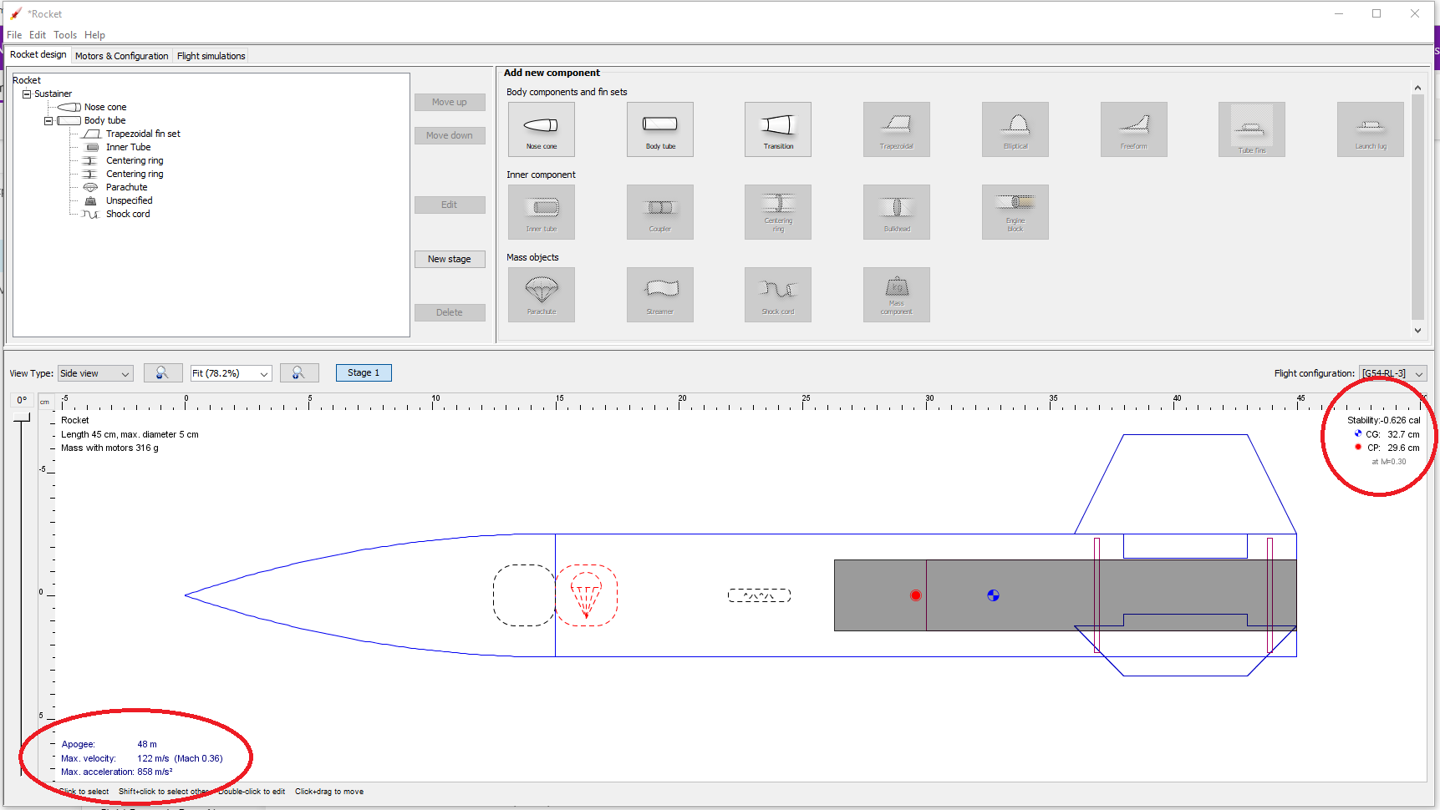

CG: Center of Gravity

CP: Center of Pressure

CP must be in front of (towards nose cone) CG

Ensure that your stability is a minimum of 1.5!   
Recognize a balance between Stability and Apogee.

To ensure accuracy, override the mass of components.

# **ROCKET BUILDING**

1. Obtain materials:
   1. 3 Fins
   2. Two standard rail buttons assemblies
   3. Body tube
   4. Engine tube
   5. Parachute
      1. Kevlar
      2. String
      3. Nylon sheet
      4. Duct tape
      5. Carabiner
   6. Nose cone
   7. Engine retainer
   8. 5 minute epoxy
   9. Engine casing retainer
   10. Centering rings x2
2. Cut fin tabs
   1. Bandsaw to rough shape
   2. Fin tab sanded to fit body tube slots
   3. Chamfer sanded on every side but fin tab side
3. Attach rail buttons
   1. Aligned axially, so that the fins are furthest from the rail
   2. One is 1" from bottom of body tube, other halfway up body tube
4. Cut 2 holes in each of the centering rings, 180deg apart from each other.
5. Epoxy top centering ring onto outside of engine tube such that it is right above the fin tabs when it's installed
6. Epoxy bottom centering ring onto outside of engine tube such that it sits right below the fin tabs when installed
7. Cut Kevlar to 2-3x length of total rocket, feed kevlar through all four centering ring holes and tie off. Excess kevlar should be connected to parachute.
   1. Tie one end (bowline knot) of string to a vertex and the other to the vertex directly opposite
   2. Connect all of the strings to a carabiner and swivel
8. Engine Assembly
   1. Insert engine tube such that the engine tube sticks out of the body tube so there is enough length for the casing retainer to be epoxied on later
   2. Epoxy casing retainer onto engine tube
9. Attach fins, epoxy on bottom of fin insert and chamfer epoxy on outside of tabs.
10. Let everything dry and prepare the parachute while you wait.
11. Given the mass of the rocket, calculate an acceptable diameter for your circular/hexagonal parachute.
12. Duct tape 6 vertices for reinforcement, hole punch through each
13. Fold it all up into a triangle, estimate an appropriate slip hole (1/10 of the outer parachute diameter)
14. Attach nose cone at the midpoint of the Kevlar between the carabiner and the body tube attachment.
15. Feed through hole in wadding
16. Epoxy engine casing retainer onto the exposed end of engine tube
17. Tie altimeter to the carabiner
18. Fold parachute into triangle, roll from slip-hole to outer edge
19. Wrap the parachute with the strings
20. Wrap the wadding around the aft end of the parachute and slide through the body tube, the rest of the kevlar and carabiner goes on top, fit the nose cone on top of everything.
21. Once assembled, spray paint and sand.